**Muhammad Umar Ahmadzai**

**09/15/2017**

**Extra Assignment: Lottery**

**Problem Statement:**

This program is going to ask the user to input two guess number. They will be stored and compared to the random number that is generated by the computer. It will output the results that are defined in the if else statements.

**Input/output Description:**

**User will be asked to input the guessed number and it will be stored:**

cout << endl << " Please enter your first guess number: ";

cin >> firstguessnumber;

cout << " Please enter your second guess number: ";

cin >> secondguessnumber;

**Within if statement, it will compare and output the result:**

if (firstguessnumber==firstrandomnumber && secondguessnumber == secondrandomnumber)

{

cout << endl << "That's exact match, you won grand price of 10000$ " << endl;

}

**Same procedure will be followed for other if else statements.**

**Algorithm Development:**

Basically, we defined six variables where it will store the user guess numbers and generate random number. Data will be stored and matched with the random number that the computer generated. It is going to compare and using If else statement it will find out if the guess number matches exactly, or digits matches, or a single digit matches. It will output the result of the user’s price won, or if he lost.

**Program Listing:**

#include <iostream>

using namespace std;

int main()

{

int firstrandomnumber,secondrandomnumber,thirdrandomnumber;

int firstguessnumber, secondguessnumber, thirdguessnummber;

srand((unsigned)time(NULL));

cout << endl << " Please enter your first guess number: ";

cin >> firstguessnumber;

cout << " Please enter your second guess number: ";

cin >> secondguessnumber;

firstrandomnumber= rand () %10;

secondrandomnumber = rand () %10;

cout << endl << " Your first random number is : " << firstrandomnumber << "." << endl;

cout << " Your secod random number is : " << secondrandomnumber << "." << endl;

if (firstguessnumber==firstrandomnumber && secondguessnumber == secondrandomnumber)

{

cout << endl << "That's exact match, you won grand price of 10000$ " << endl;

}

else if (firstguessnumber == firstrandomnumber || secondguessnumber == firstrandomnumber && firstguessnumber== secondrandomnumber || secondguessnumber == secondrandomnumber)

{

cout << endl <<"You matched the digits, you won $3000." << endl;

}

else if ( firstguessnumber == firstrandomnumber || secondguessnumber == firstrandomnumber || firstguessnumber== secondrandomnumber || secondguessnumber == secondrandomnumber)

{

cout << endl <<" You matched one digit, you won 1000$" << endl;

}

else if (firstguessnumber!= firstrandomnumber && secondguessnumber != firstrandomnumber && firstguessnumber != secondrandomnumber && secondguessnumber != secondrandomnumber)

{

cout << endl <<" None of them were correct, you lost." << endl;

}

}

**Observation and Error Handling and general comments:**

Did not faced any errors.

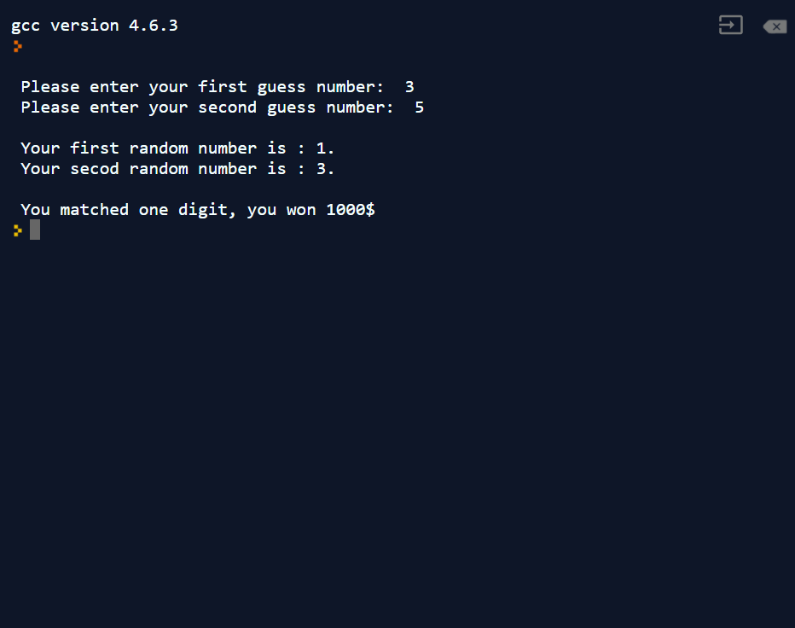

**Conclusion:**

In conclusion, it will compare random number generated by the program with user’s guess number and give an output of user winning or losing.